Welcome to the Hawke’s Bay Farmyard Zoo.
Activity Sheet
- Write down the animal’s name and answer the questions.
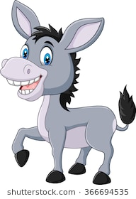
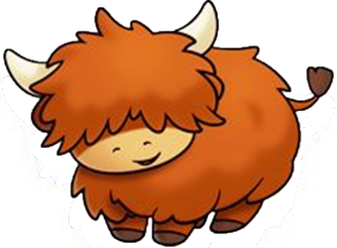
Name: __________ Name: ___________
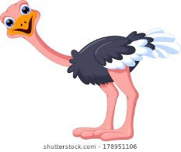
Do they have bigger ears than What colour is he?
a pony? Yes / No Brown/ Orange / Black
Name: __________
How many toes does he have?
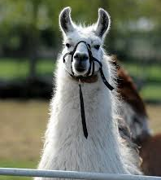
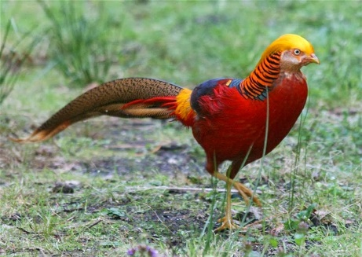
- Can you name these animals?
- ___________ b. ________________

c. _________________

C. Male Peacocks are known for their bright colours to attract females, below is a picture of a peacock, can you colour him as bright as our peacocks?
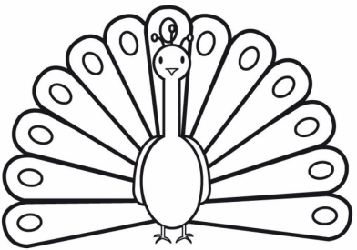

D. Can you match the baby animal to its mother?
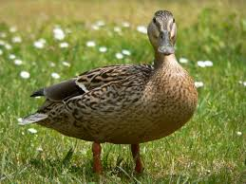
Babies Mothers

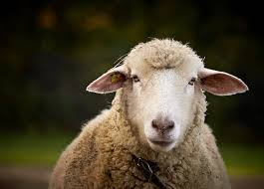
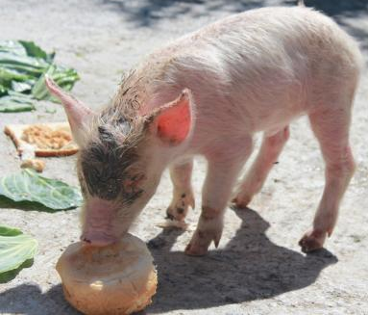

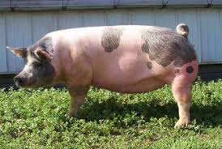
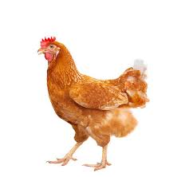
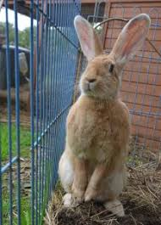
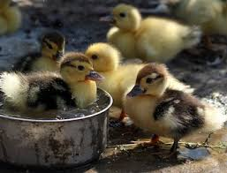
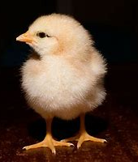

Some Fun Farmyard Facts
a. Llamas are bigger than Alpacas and we use Alpaca wool, but not lama wool.
b. Pigs are considered the fourth most intelligent animal in the world.
c. Lambs can identify their mothers by the sound of her bleat.
d. A group of pigs is called a “sounder”
e. Cattle are Red/green colour blind.
f. Horses gallop to around 44kph (27 mph).
Scavenger Hunt Check List
Can you find the animals pictured on this list?
Make a tick if you saw them at the zoo.
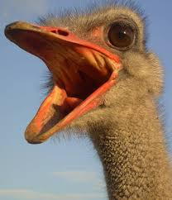
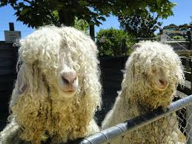
Angora goats – Curly & Fuzz Ostrich – Mr. Stretch
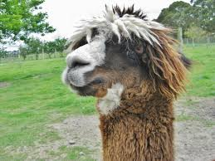

Alpaca – Rico Pony – Pebbles

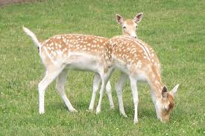
Fellow Deer

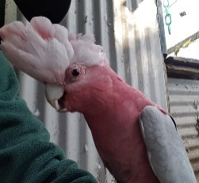
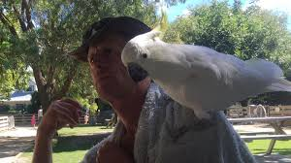
Cockatoo – Charlie Ossy - Galah

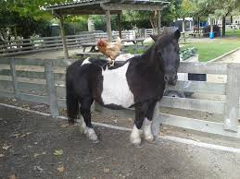
Pony – Fletcher
Some fun questions – Ask your teacher or the friendly farmyard staff
a. How many legs does Charlotte have?
b. What colour are Emu eggs?
c. What is a female horse called?
d. Name one thing we use sheep’s wool for?
e. Which two type of deer do we have at the zoo?
Thank you for visiting our zoo

